This document will demonstrate how to restore factory firmware, which can be used for brick recovery or factory burning.

1. Insert the USB into the JTAG port, and if the DONE light is on, it indicates that the FLASH boot mode has been entered. Press the BOOT-KEY button (side) briefly to enter JTAG mode.

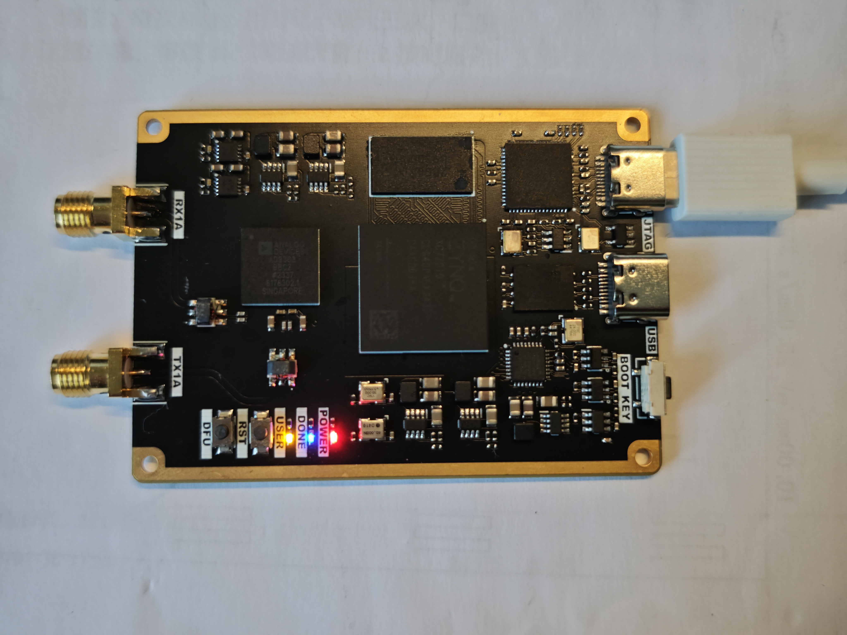

2. Open Vivado, add FLASH: mt25ql256-qspi-x4-single, and refer to the following figure to select the corresponding path and configuration:
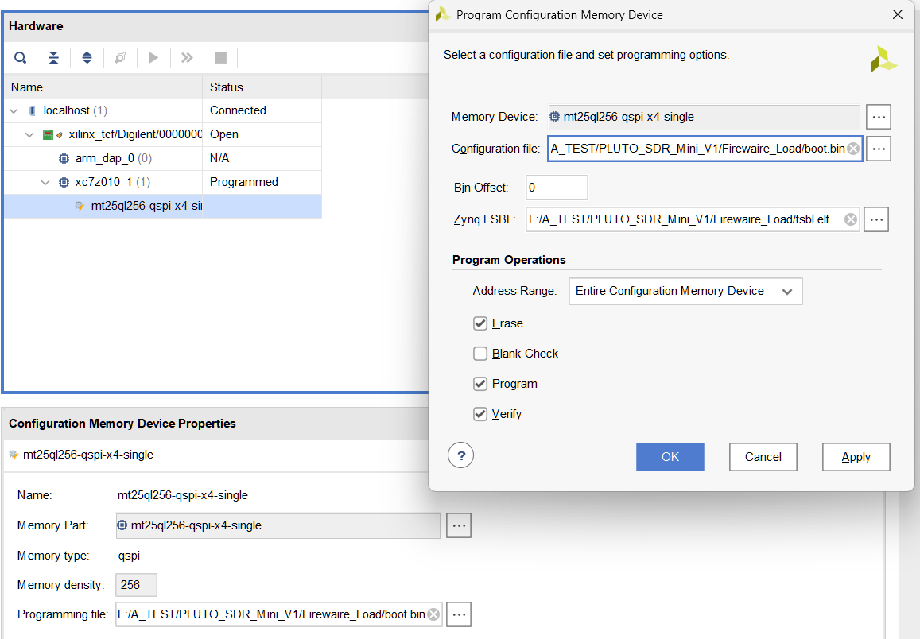
3. Wait for the flashing to complete:
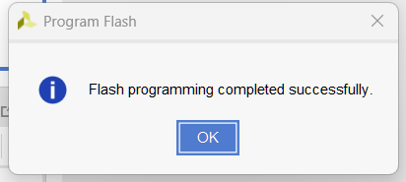
4. Power on the board again, insert the USB cable into the USB port, and wait for the USB download gadget to appear in the device manager:
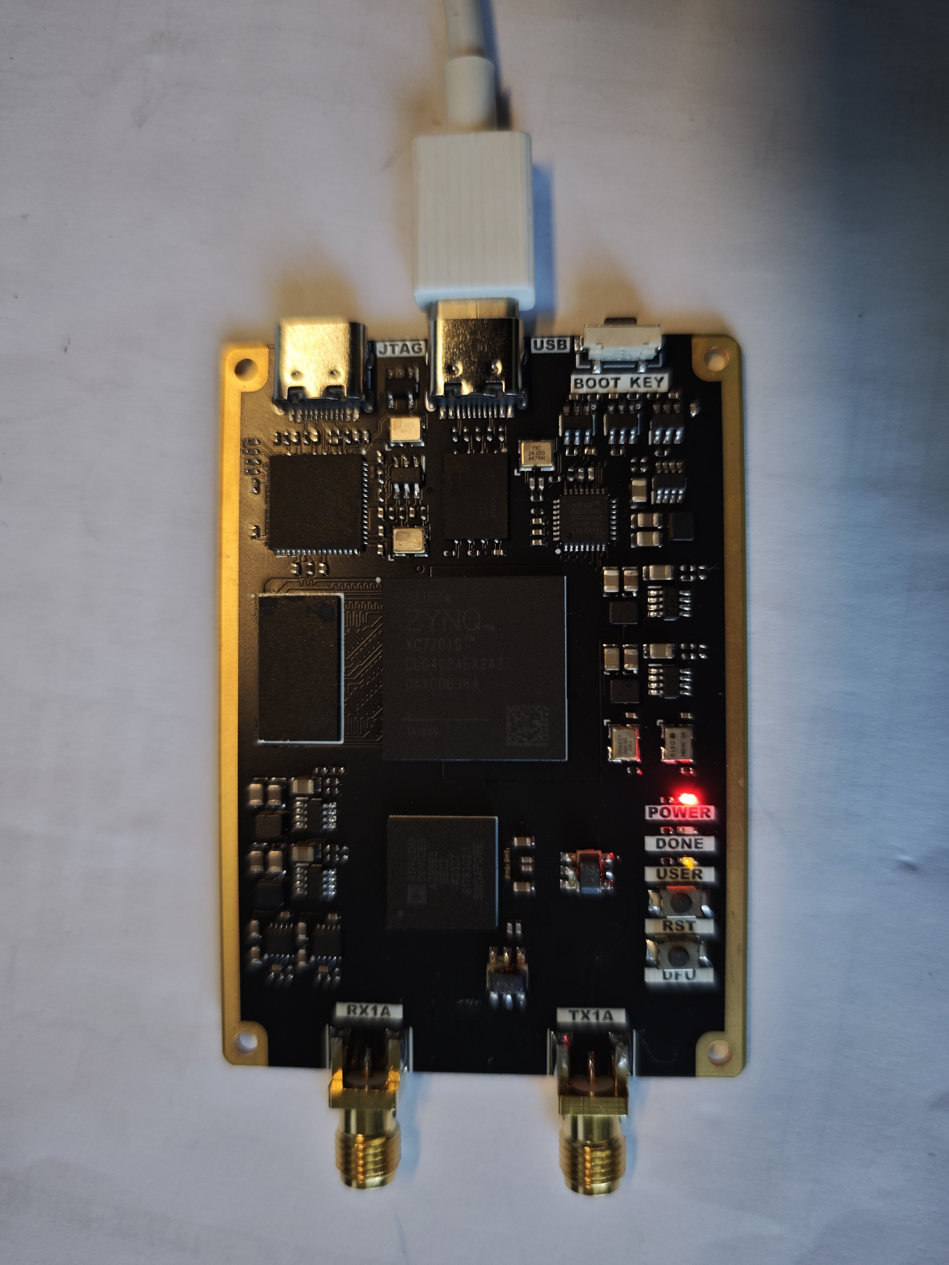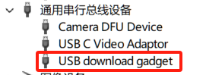
5. Run the two instructions in the instructions, wait for the run to end, then power off and restart
